به نام خداوند بخشنده مهربان

متا شاپِرز

Meta Shoppers

مستندات نرم‌افزار

مهربد ملاکاظمی خوبده

استاد راهنما: جناب آقای دکتر پوریا خانزادی

ترم 4022

دانشگاه آزاد اسلامی واحد تهران شمال

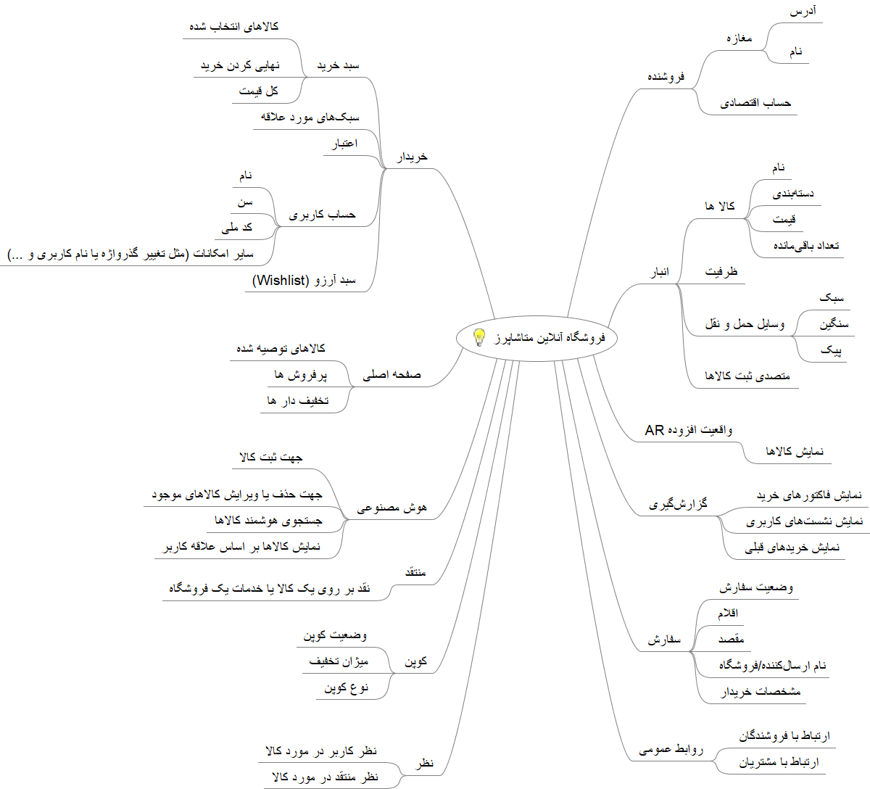

// File: metashoppers.DSL

// Developer: Mehrbod Molla Kazemi

// Professor: Dr. Pourya Khanzadi

/** Mogram **/

meta shopper website

seller

customer

product

inventory

order

coupon

critic

comment

ai

landing page

cart

wishlist

warehouse keeper

/** Informal Definition **/

MetaShoppers website is a brand-new e-commerce store (B2C), with the power of AI to enhance productivity.

/** Symbols Definition **/

Symbol Definition

----------------------------------------

MSW Meta Shoppers Website

SEL Seller

CUST Customer

INV Inventory

ORD Order

COP Copoun

CRIT Critic

COMM Comment

AI Artificial Intelligence (AI)

LAND_P Landing Page

PROD Product

CART Cart

WISHL Wishlist

WHK Warehouse Keeper

=> Forward Interaction

<= Backward Interaction

<=> Two-Way Interaction

=? Vague Interaction

? Unknown Entity

* EVERY ELEMENT AVAILABLE

/** VERY GENERAL Scenario **/

Assuming that MSW supports Shop-To-Go (Order without logging in!),

A CUST surfs on the internet and finds MSW, and they decide to visit it. They arrive at LAND_P.

They may look for a PROD they desire that is provided by a SEL, so they search it on MSW.

If they find the PROD they are looking for, then they may look at its price. If satisfied, they'll add it to their CART.

On the other hand, if the item is too expensive/not available at the moment, they may add the PROD to their WISHL.

INV is always checked to update availability of current PRODs.

When done, the CUST will finalize their CART.

They may provide a COP for discount, so its validity must be checked.

Afterwards, they will be taken to the payment page.

If the result of transaction is successful, an ORD is submitted for the user with a unique ID which can be tracked.

WHK may manipulate products, which the process can become way easier with the help of AI. They can read a PROD's barcode, and then it is submitted in INV (an example).

A CUST may empty their WISHL.

Some CUST or approved CRITs may leave COMMs under PRODs pages.

/** Numerical constants **/

Not anything meaninful to be taken care of at the moment... Assume all N.

/** Interactions **/

MSW <=> *

CUST, SEL => PROD

WHK => PROD

CUST => ORD

LAND_P <= CUST, SEL, PROD

CART <=> WISHL

CUST => WISHL, CART

SEL =? WHK

AI <=> CUST, SEL, WHK

|  |  |  |  |
| --- | --- | --- | --- |
| In the name of God | | | |
| **MetaShoppers Software - Dictionary** | | | |
| واژه | نوع | معادل انگلیسی | |
| تولیدکننده | Noun | Manufacturer | |
| فروشگاه | Noun | Store | |
| کالا | Noun | Product | |
| مشتری (خریدار) | Noun | Customer | |
| انبار | Noun | Inventory | |
| منتقد | Noun | Critic | |
| پیک | Noun | Delivery | |
| کوپن | Noun | Coupon | |
| سبد خرید | Noun | Cart | |
| نظر | Noun | Comment | |
| سبد آرزو | Noun | Wishlist | |
| حساب کاربری | Noun | Account | |
| روابط عمومی | Noun | Support | |
| سفارش | Noun | Order | |
| مدیریت فروشگاه‌ها | Verb | Manage Stores | |
| مدیریت انبار | Verb | Manage Inventory | |
| ارسال کالا | Verb | Send Product | |
| توصیه کالا | Verb | Suggest Product | |
| اضافه به سبد خرید | Verb | Add To Cart | |
| اضافه به آرزوها | Verb | Add To Wishlist | |
| مقایسه کالا | Verb | Compare Products | |
| نهایی کردن خرید | Verb | Finalize Purchase | |
| گرفتن گزارش | Verb | Get Report | |
| ثبت نظر | Verb | Submit Comment | |
| بررسی کوپن تخفیف | Verb | Coupon | |
| جستجوی کالا | Verb | Search Product | |
| پیگیری سفارش | Verb | Track Order | |

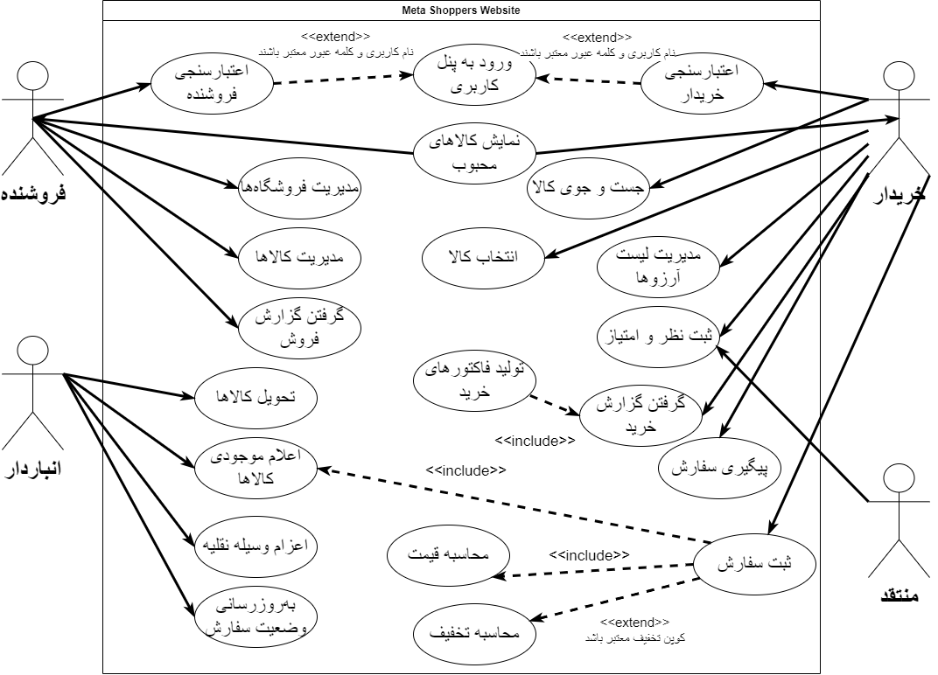

















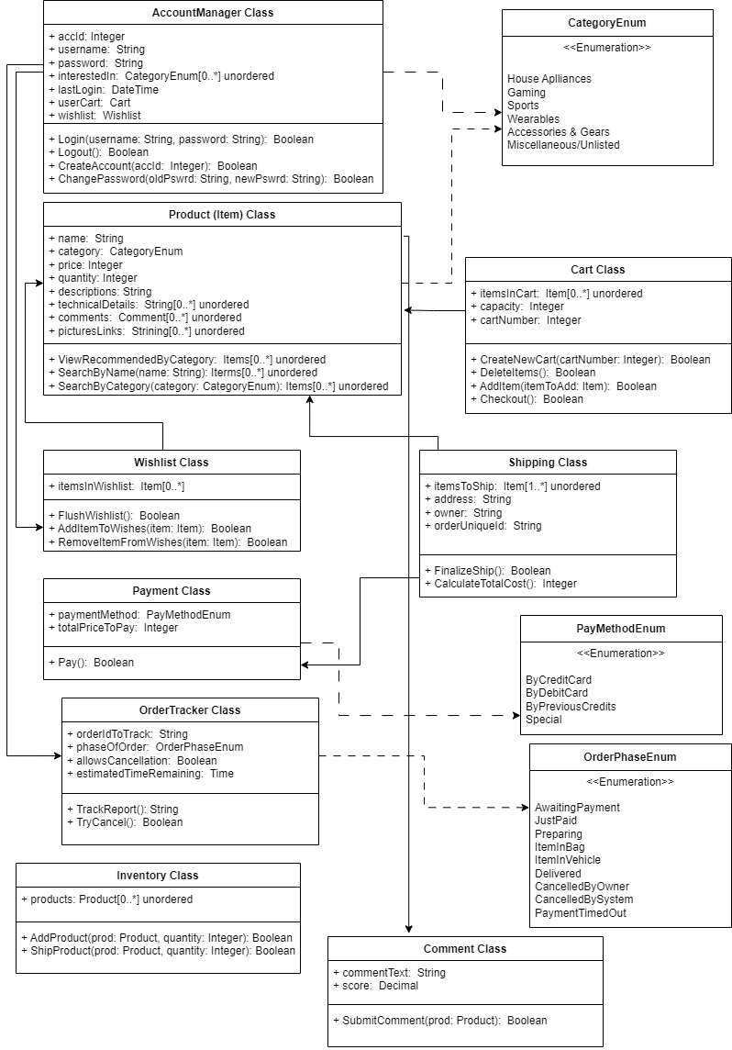

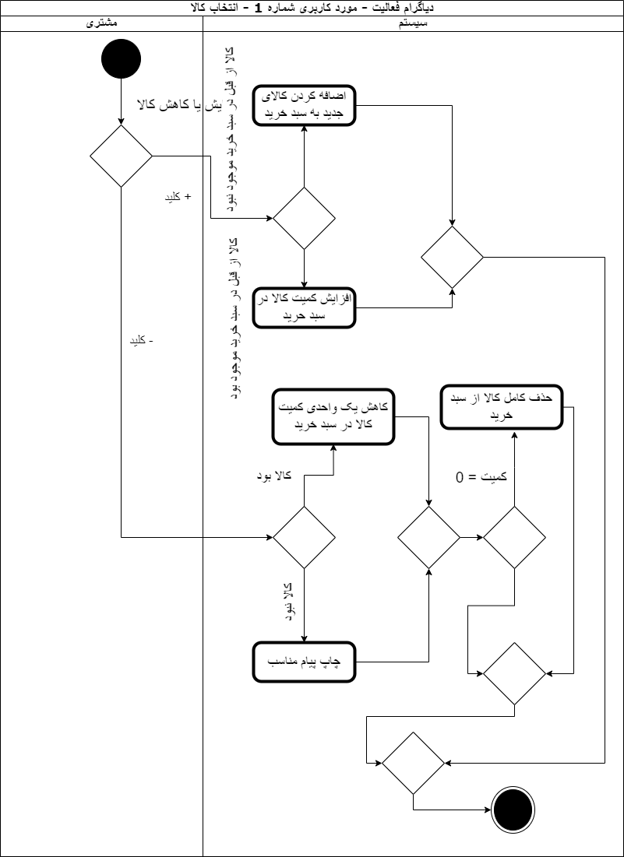

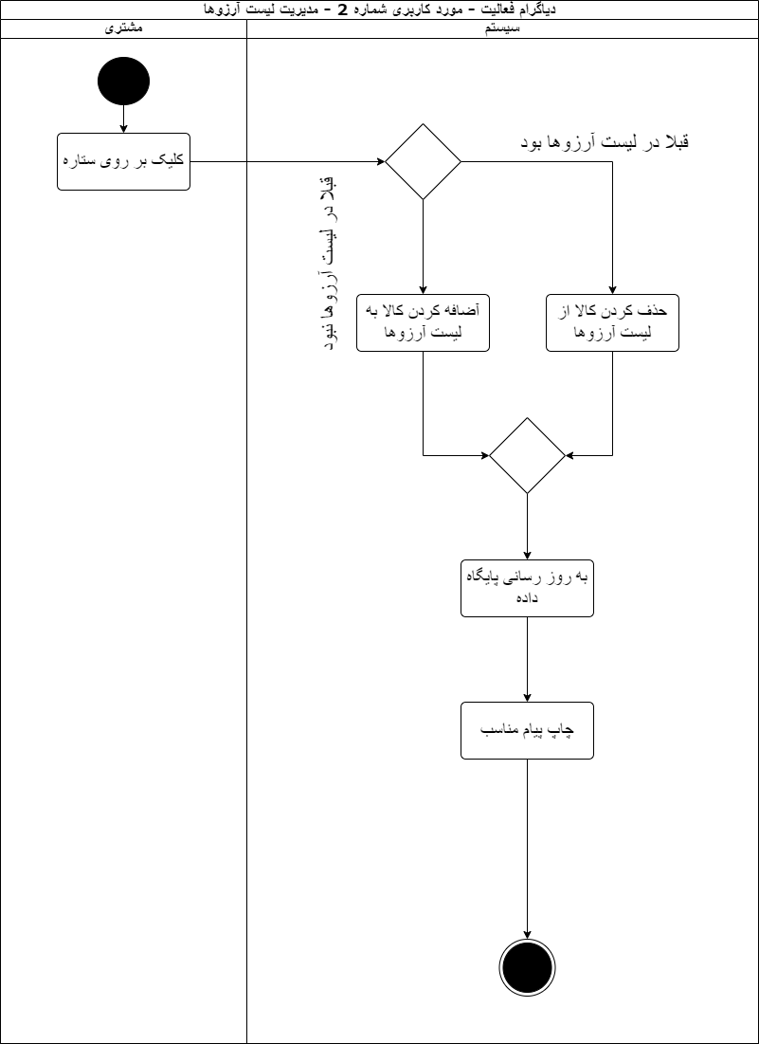

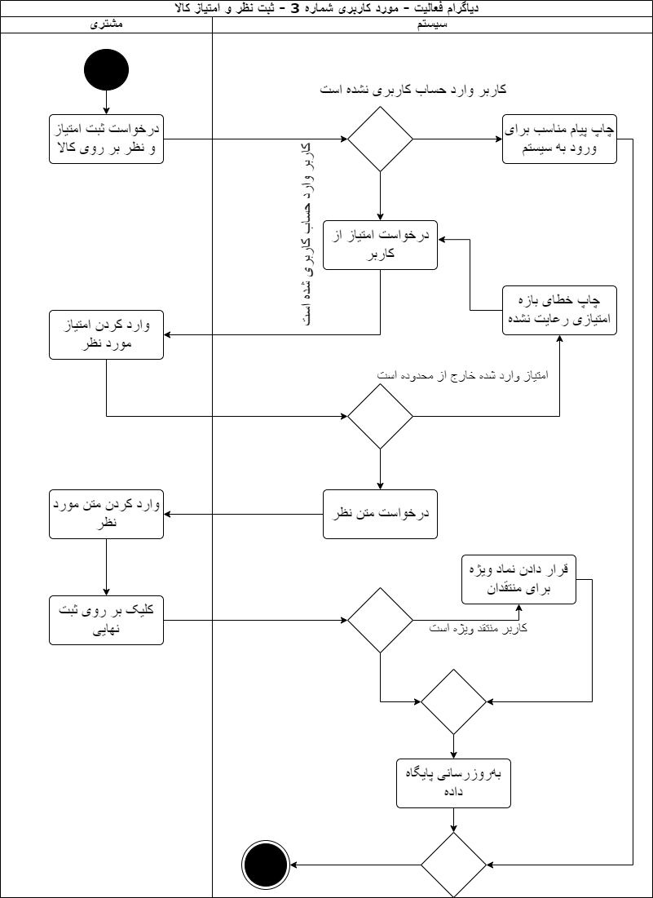

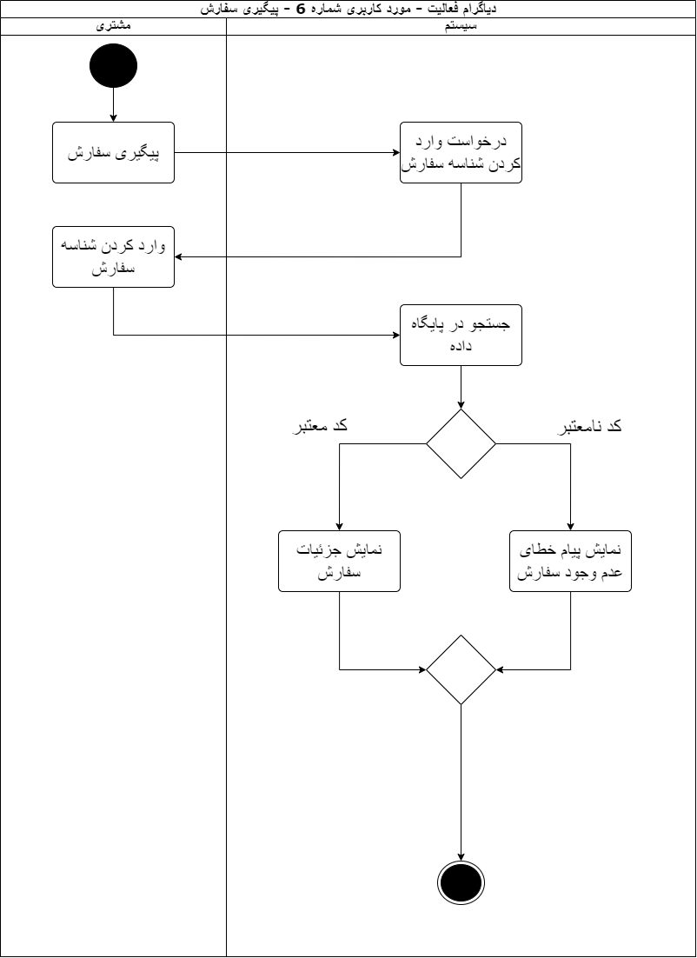

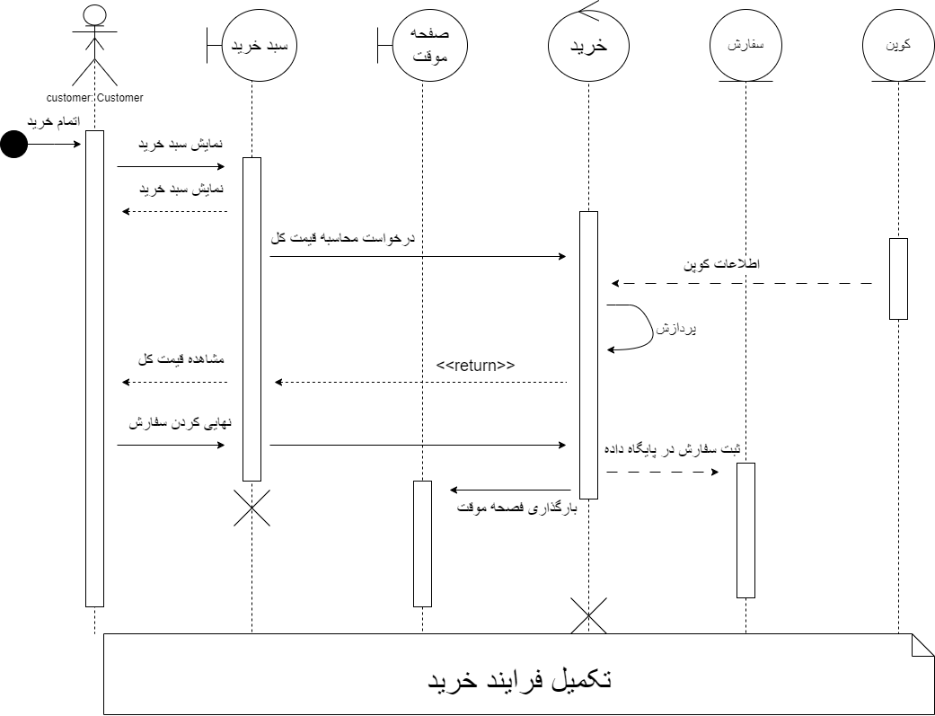

|  |  |  |  |  |  |  |  |  |  |
| --- | --- | --- | --- | --- | --- | --- | --- | --- | --- |
| **Manufacturer** | | | | | | | | | |
| Attributes | | | | | Operations | | | | |
| ManufacturerID | | | | 1 | Add To Products() | | | | 1 |
| Name | | | | 2 | Manage Stock() | | | | 2 |
| Products Available | | | | 3 | Manage Profile() | | | | 3 |
| Date Established | | | | 4 | Get Report() | | | | 4 |
| Rating | | | | 5 |  | | | |  |
| Sales | | | | 6 |  | | | |  |
|  | | | |  |  | | | |  |
| **Store** | | | | | | | | | |
| Attributes | | | | | Operations | | | | |
| StoreName | | | | 1 | Manage Products() | | | | 1 |
| Products | | | | 2 | Manage Customers() | | | | 2 |
| Customers | | | | 3 | Manage Manufacturers() | | | | 3 |
| Manufacturers | | | | 4 | Manage Orders() | | | | 4 |
| Critics | | | | 5 | Manage Inventory() | | | | 5 |
| Orders | | | | 6 |  | | | |  |
| Inventory | | | | 7 |  | | | |  |
| Coupons | | | | 8 |  | | | |  |
|  |  |  |  |  |  |  |  |  |  |
| **Product** | | | | | | | | | |
| Attributes | | | | | Operations | | | | |
| ProductID | | | | 1 | Update Quantity() | | | | 1 |
| Name | | | | 2 | Transfer Ownership() | | | | 2 |
| Quantity | | | | 3 | Send To Inventory() | | | | 3 |
| Manufacturer | | | | 4 |  | | | |  |
| DateAdded | | | | 5 |  | | | |  |
| DateUpdated | | | | 6 |  | | | |  |
| IsOnSale | | | | 7 |  | | | |  |
| Price | | | | 8 |  | | | |  |
| NumberOfPurchases | | | | 9 |  | | | |  |
| Comments | | | | 10 |  | | | |  |
| Rating | | | | 11 |  | | | |  |
|  |  |  |  |  |  |  |  |  |  |
| **Customer** | | | | | | | | | |
| Attributes | | | | | Operations | | | | |
| CustomerID | | | | 1 | Add To Cart() | | | | 1 |
| FirstName | | | | 2 | Change Password() | | | | 2 |
| LastName | | | | 3 | End Session() | | | | 3 |
| NationalID | | | | 4 | Finalize Purchase() | | | | 4 |
| DateJoined | | | | 5 | Empty Cart() | | | | 5 |
| NumberOfOrders | | | | 6 | Add To Wishlist() | | | | 6 |
| NumberOfPurchases | | | | 7 | Empty Wishlist() | | | | 7 |
| Rank | | | | 8 |  | | | |  |
| Friends | | | | 9 |  | | | |  |
| Interests | | | | 10 |  | | | |  |
| Cart | | | | 11 |  | | | |  |
| Wishlist | | | | 12 |  | | | |  |
| Interests | | | | 13 |  | | | |  |
| **Inventory** | | | | | | | | | |
| Attributes | | | | | Operations | | | | |
| ProductsInInventory | | | | 1 | Add To Inventory() | | | | 1 |
| OrdersPending | | | | 2 | Submit Order() | | | | 2 |
| DeliveriesAvailable | | | | 3 | Remove From Inventory() | | | | 3 |
| MaximumCapacity | | | | 4 | Mark Order as Done() | | | | 4 |
|  | | | |  | Get Report() | | | | 5 |

پایان

با تشکر از توجه شما

مهربد ملاکاظمی خوبده

1 خرداد 1403